**How to Setup the backend**

*Let consume domain name **xyz** (<https://xyz.com>)

**\* Please Don’t delete anything from the database directly**

**Follow these simple steps to setup your backend**

1. Download the zip files
2. Upload the zip files on your server, unzips the folder under the **public_html**

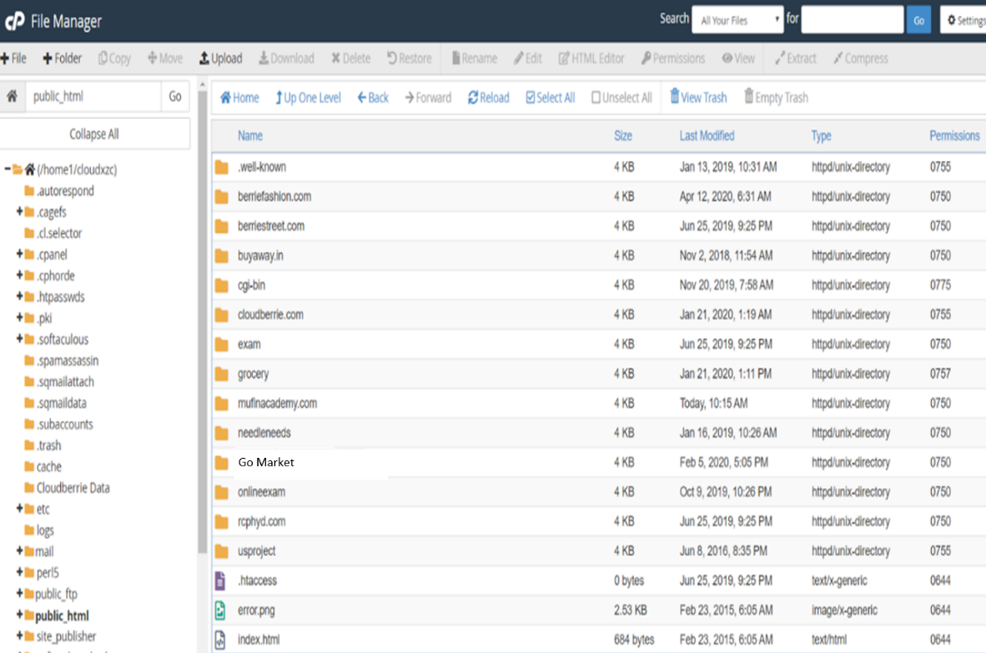

1. Hit the url into the browser <https://xyz.com/Go>Market/admin you can get the activator page

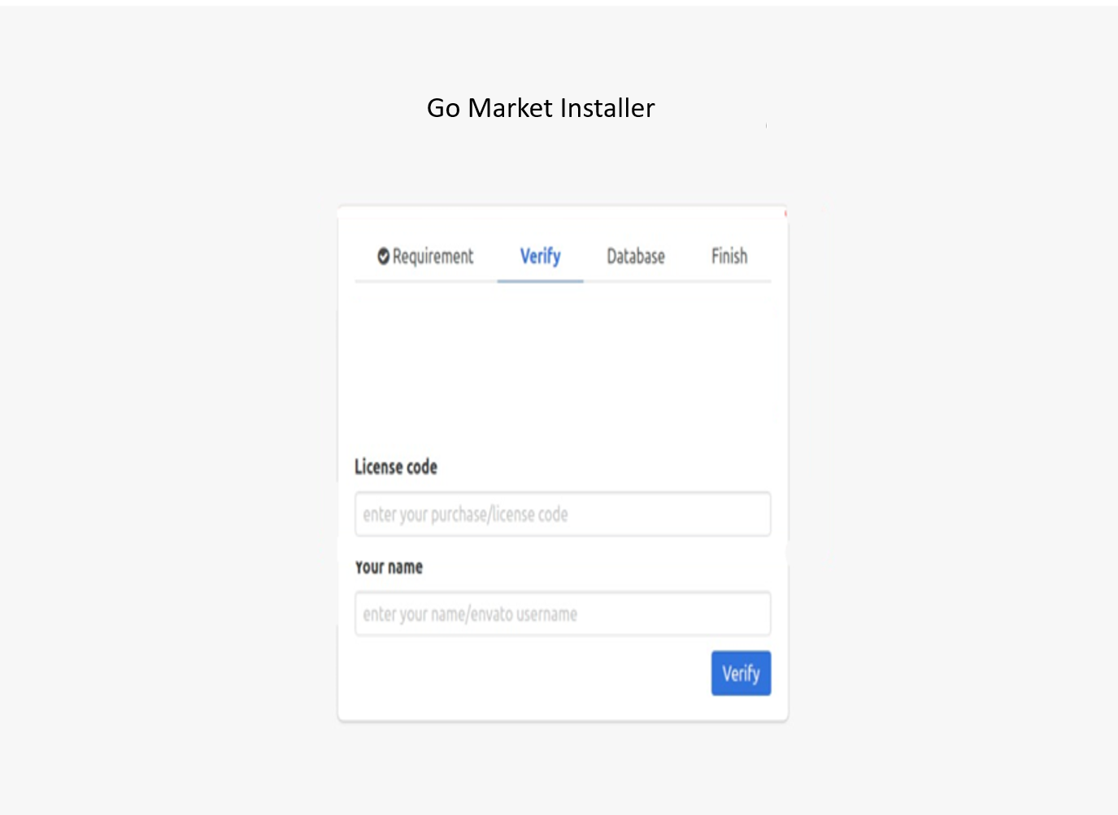

1. Create a new database ( copy the database name & password)

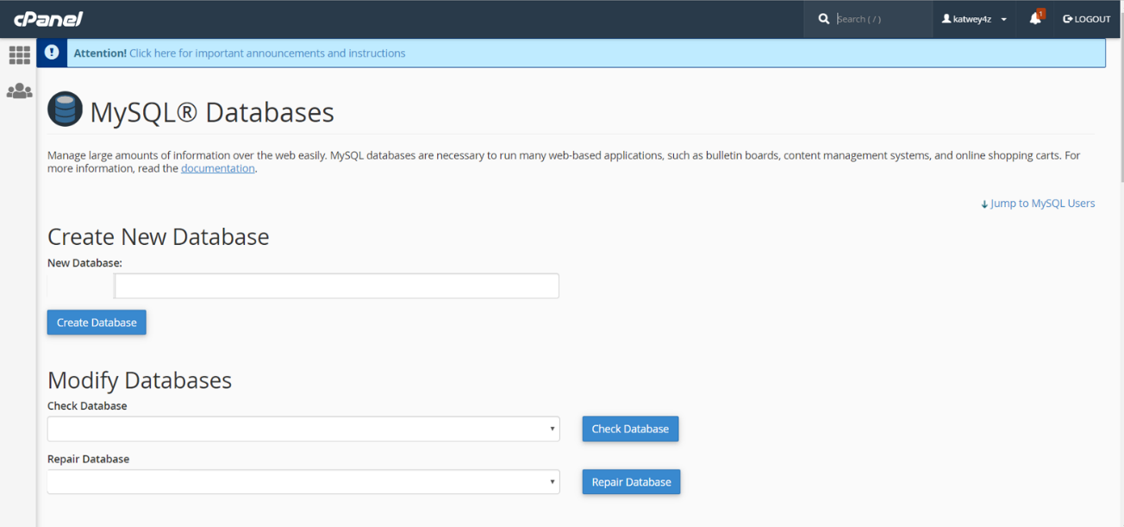

1. After successfully creating the database, go to the browser open the same url https://xyz.com/goservices/admin
2. Use the license code & Name which you get in the invoice



1. After verifying the license code, use database credentials which you have copied earlier

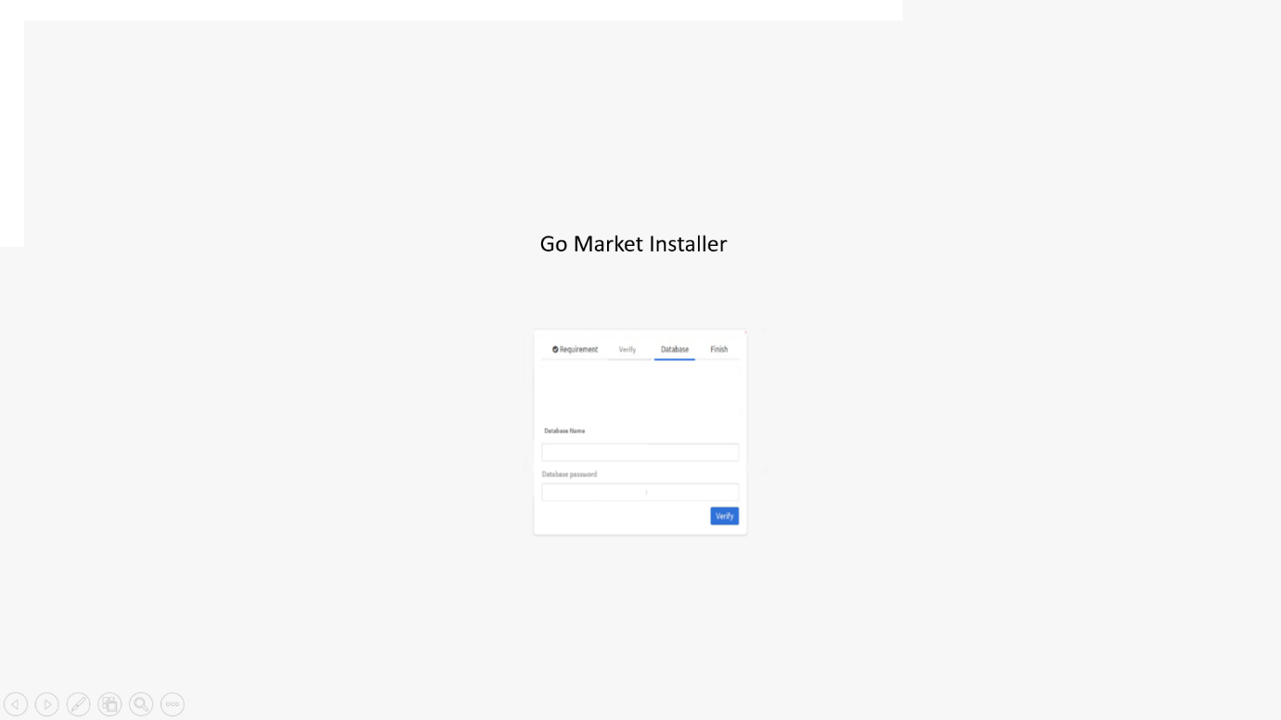

1. After submitting all the details you have saw the welcome page after that you have to hit the url in the browser

<https://xyz.com/GoMarket/admin> & you will saw this page

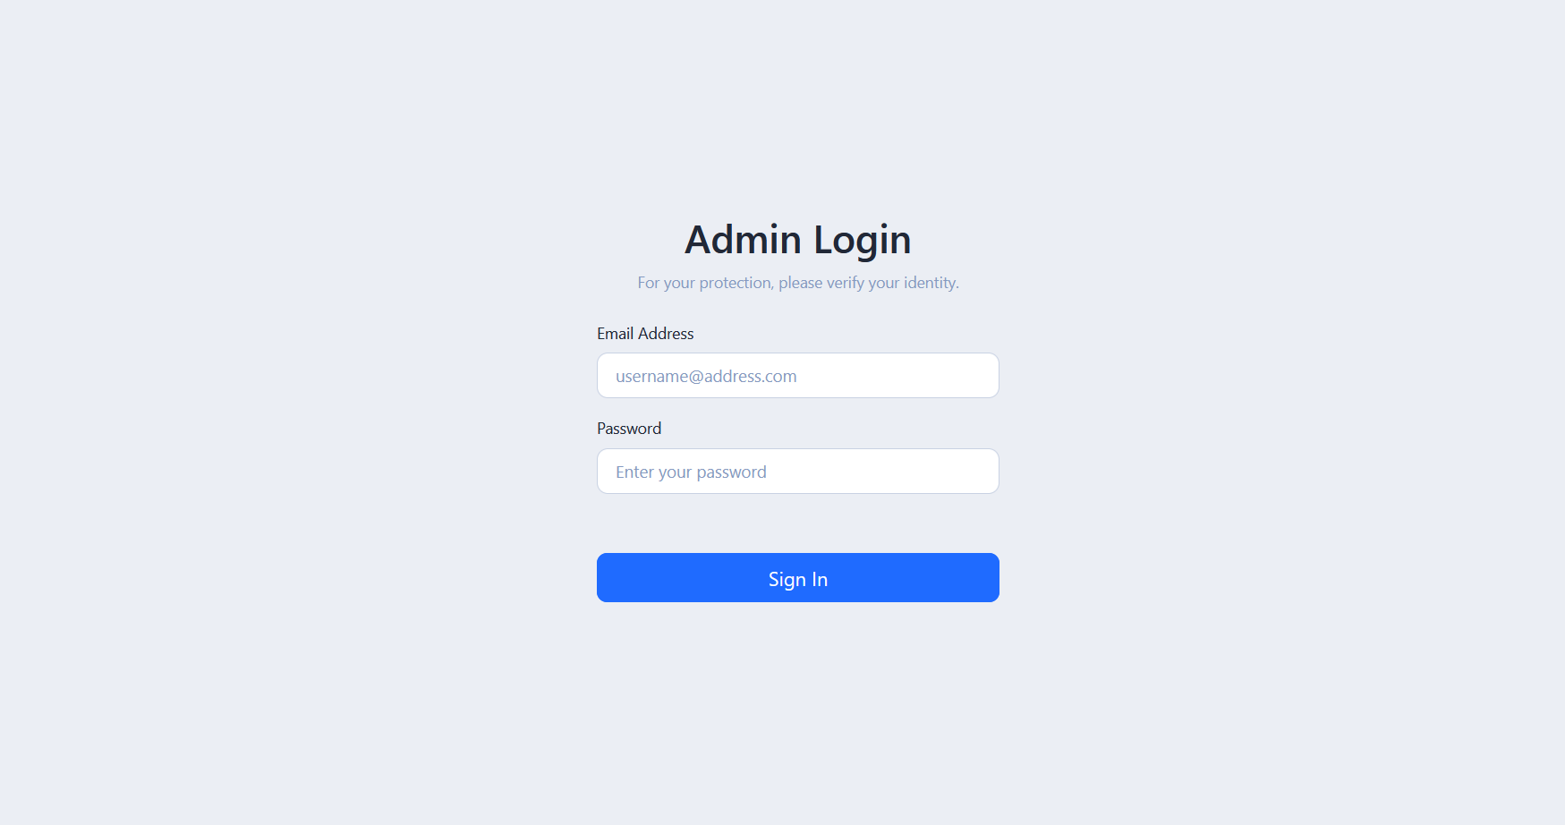

1. **Credential:**

**Admin Login :  
E-mail: support@tecmanic.com**  
**password:** admin

**Other Panel Links**

**\*Sub- Admin\***

[https://xyz.com/GoMarket/](https://xyz.com/GoMarket/grocery)cityadmin

**\*Grocery\***

<https://xyz.com/GoMarket/grocery>

**\*Restaurant\***

[https://xyz.com/GoMarket/](https://xyz.com/GoMarket/grocery)restaurant

**\*Pharmacy\***

[https://xyz.com/GoMarket/](https://xyz.com/GoMarket/grocery)pharmacy

**\*Parcel\***

[https://xyz.com/GoMarket/](https://xyz.com/GoMarket/grocery)parcel

**7. For Apps**

base url: <https://xyz.com/GoMarket/api/>

**For user App, Driver App, Vendor App**

Img url: <https://xyz.com/GoMarket/>

**For user App, Driver App, Vendor App**

1. **How to create a google Map api key**

You have to create google map api key by your own via below link- You have to create google map api key by your own via below link- https://console.cloud.google.com/google/maps-apis/overview

Note- Add card in Billing section is mandatory when you create google map api key. Check your google map api key with this link and enable all APIs from goolge map console.

https://maps.googleapis.com/maps/api/geocode/json?latlng=-27.0000,133.0000&key=Place your google map api key here

see the attached screenshot i you will get response like that it means your map api key is working.otherwise your map api key is not working.

Note- Add card in Billing section is mandatory when you create google map api key. Check your google map api key with this link and enable all APIs from goolge map console.

https://maps.googleapis.com/maps/api/geocode/json?latlng=-27.0000,133.0000&key=Place your google map api key here

see the attached screenshot i you will get response like that it means your map api key is working.otherwise your map api key is not working.

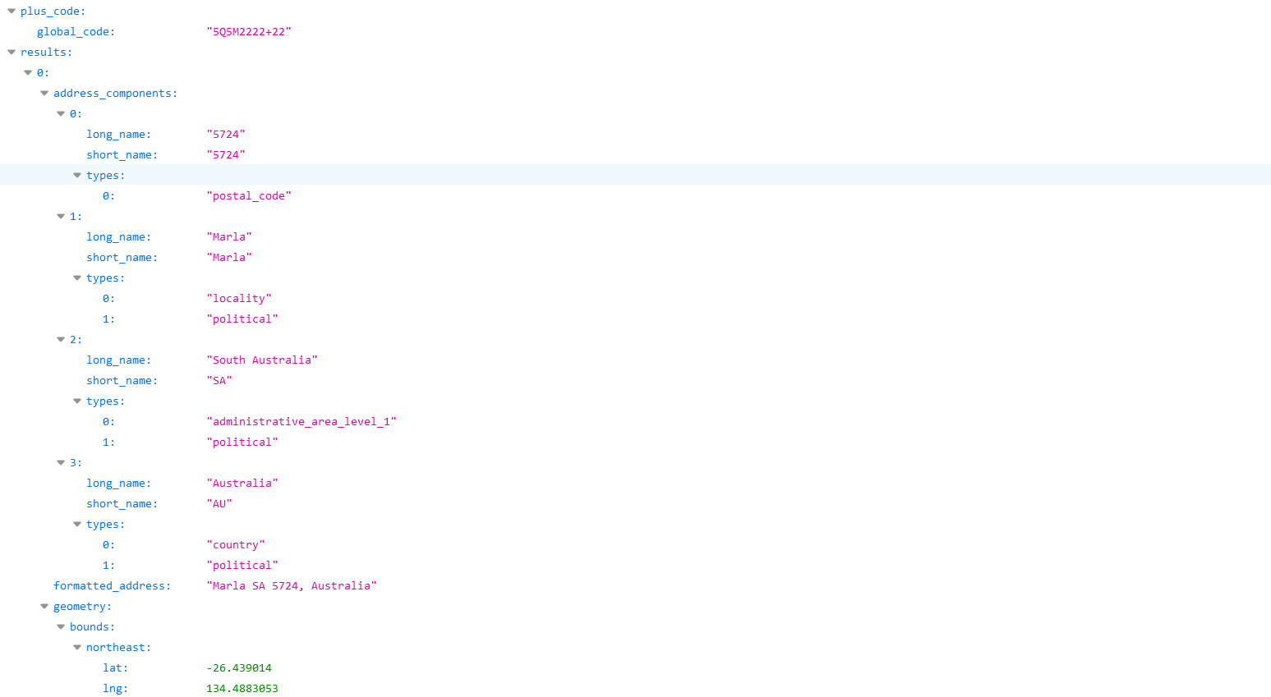

1. **How to create your mail SMTP**

you have to setup your SMTP from source/.env

MAIL_DRIVER=smtp

MAIL_HOST=smtp.gmail.com

MAIL_PORT=465

MAIL_USERNAME=smtp mail

MAIL_PASSWORD= smtp password

MAIL_ENCRYPTION=ssl

you can create gmail smtp credentials by following steps from below link-

https://medium.com/graymatrix/using-gmail-smtp-server-to-send-email-in-laravel-91c0800f9662

**10.How to change the default to yours**

Open the project

GoMarket /app/Traits/SendMail.php

When you open this file search [noreply@gomarket.in](mailto:noreply@gomarket.in)

& replace with your mail &

After that your backend is successfully setup